ANUDIP FOUNDATION

**“Voting System”**

|  |  |
| --- | --- |
| **Name** | **Enrollment No** |
| **Sairaj Mohan Pawar** | **AF0481893** |
| **Nikam Vivek Gunvant** | **AF0484020** |

**Under Guidance**

**Of**

**Rajashri Thete**

**ACKNOWLEDGEMENT**

The project **“Voting System”** is the Under the Guidance.

|  |  |
| --- | --- |
| **Name** | **Enrollment No** |
| **Sairaj Mohan Pawar** | **AF0481893** |
| **Nikam Vivek Gunvant** | **AF0484020** |

Under the Guidance,

I am thankful to my project guide for providing valuable guidance, constant support, and encouragement throughout the completion of this project. Her suggestions and advice have been extremely helpful in shaping the project and preparing this project report.

I am also grateful to my family members and friends for their continuous support, encouragement, and motivation, which helped me successfully complete the project.

**Index**

|  |  |  |  |
| --- | --- | --- | --- |
| 1. |  | Title of the Project |  |
|  |  |  |  |
| 2. |  | Introduction /Objective |  |
|  | 2.1 | Introduction | 7 |
|  | 2.2 | Objective | 8 |
|  |  |  |  |
| 3. |  | System Analysis |  |
|  | 3.1 | Problem Definition | 9 |
|  | 3.2 | Preliminary Investigation | 9-11 |
|  | 3.3 | Feasibility Study | 12-13 |
|  | 3.4 | Project Planning | 14 |
|  | 3.5 | Project Sheduling | 14-15 |
|  | 3.6 | Software Requirement Specification | 16-18 |
|  | 3.7 | Functional Requirements | 19-20 |
|  | 3.8 | Software Engineering Paradigm | 21-23 |
|  | 3.9 | Data Model Description | 24-30 |
|  |  |  |  |
| 4. |  | System Design |  |
|  | 4.1 | Modularization Details | 31 |
|  | 4.2 | Database Design | 32-33 |
|  | 4.3 | Procedural Design | 34 |
|  | 4.4 | User Interface Design | 35-38 |
|  | 4.5 | Outputs of the Report | 39-42 |
|  |  |  |  |
| 5. |  | Coding |  |
|  | 5.1 | Complete Project Coding | 43-58 |
|  | 5.2 | Validation Check | 59-60 |
|  |  |  |  |
| 6. |  | Testing |  |
|  | 6.1 | Testing Strategies | 61-62 |
|  |  |  |  |
| 7. |  | Reports | 63-65 |
|  |  |  |  |
| 9. |  | Future Application of the Project | 66 |
|  |  | Conclusion | 67 |
| 10. |  | Bibliography | 68 |

Voting System

**ABSTRACT**

**Voting System** is a web-based project developed using Django and MySQL that provides a user-friendly platform to conduct elections online from anywhere at any time. In today's digital world, online voting systems are the most convenient and time-saving solution compared to traditional paper-based voting. Institutions and organizations find it easier to manage elections through such systems, as the internet is a widely accessible medium.

People prefer online voting because it saves time, provides transparency, and enables voters to cast their votes securely without physical presence. This Voting System is easy to understand, simple to use, and offers fast and secure voting through a point-and-click interface.

Through this project, we present a complete solution for managing elections. The system is designed for election organizers and administrators to create polls, manage voter details, and view results efficiently. The intuitive interface makes day-to-day tasks like poll creation, voting, and result viewing easy for both users and administrators. Admin manages backend functionalities like election setup, user management, and result declaration, ensuring secure and transparent elections.

**INTRODUCTION**

Voting is one of the most important and fundamental activities in any democratic society, serving as the very backbone of a free and fair government. It empowers citizens by giving them the authority and voice to choose their representatives, leaders, and policymakers, ensuring that their interests and needs are addressed. Traditionally, voting has been conducted through physical means, requiring voters to personally visit polling stations, wait in long queues, and cast their ballots manually. This method, while effective, often involves logistical challenges, time consumption, and substantial paperwork.

However, with the rapid advancement of modern technology, online voting systems have emerged as a more efficient, secure, and accessible alternative. These systems are revolutionizing the traditional voting process by allowing individuals to participate in elections from the comfort of their homes or workplaces, thus making the entire experience more convenient and inclusive.

The "Voting System" project is a web-based application meticulously developed using the Django web framework and a robust MySQL database. It is designed to provide a highly user-friendly, intuitive, and responsive platform for organizing elections seamlessly online. This system empowers users by allowing them to securely log in using their credentials, cast their votes digitally, and view real-time election results instantly, from anywhere and at any time, using any internet-enabled device.

By implementing such an online system, it significantly saves valuable time for both organizers and participants, reduces the burden of managing physical paperwork, minimizes human errors, and enhances transparency and accountability throughout the voting process. It ensures that each vote is counted accurately and that tampering or manipulation is virtually eliminated through secure backend protocols.

Through this innovative project, we aim to offer a comprehensive, end-to-end solution for conducting elections in a wide range of environments, including educational institutions like colleges and universities, corporate companies, non-profit organizations, residential communities, and other professional or social institutions. The system is equipped with a variety of essential features such as new user registration, password-protected secure login, election creation and management by administrators, voting access restricted to eligible users, and instant result computation and display.

The Voting System ensures that every election is managed efficiently, every vote is securely handled, and every result is transparently delivered. With its reliable architecture, ease of use, and focus on security, the Voting System stands as a modern, trustworthy, and indispensable tool for organizing democratic events in today’s fast-paced digital world.

**OBJECTIVES OF THE PROJECT**

This project is designed for conducting elections through an online voting system. Managing elections manually can be time-consuming and difficult. Therefore, this project provides an online platform for organizing elections easily and securely. The various objectives of the project are as follows:

* Provide anytime, anywhere access for voters to cast their votes online.
* Minimize the number of staff required to manage offline election processes.
* Promote digitalization and modernization of traditional election processes.
* Increase election efficiency by minimizing manpower and infrastructure costs.
* Obtain statistical data of voting patterns for better analysis and planning.
* Ensure convenient and quick voting through the Internet, encouraging higher participation.
* Enhance organizational image by using a tech-savvy, modern voting system.
* Provide secure and confidential electronic voting using encrypted authentication mechanisms.

**PROBLEM DEFINATION**

**Problems faced by an individual due to lack of security are as follows:**

➤ **Loss of Personal Information:**  
If adequate security measures are not implemented, the personal information of voters, such as their identity details and voting preferences, will no longer remain confidential.

➤ **Misuse of Sensitive Data:**  
The exposed voter data can be misused in various ways, such as unauthorized publication, manipulation of voting results, or even targeting users for malicious activities.

➤ **Issues with Concurrent Access:**  
Another critical problem arises in handling multiple users accessing the system simultaneously. Without proper concurrency management, the system may crash, freeze, or allow data corruption during peak voting hours.

➤ **Decline in Trust in Digital Platforms:**  
In other words, if security is compromised, trust in digital voting systems and online platforms will gradually diminish. Like statistics, the true strength of a voting system lies in how securely it hides and protects sensitive information.

**PRELIMINARY INVESTIGATION**

**Purpose:**  
This project is designed to provide a secure and efficient platform for online voting, allowing users to vote digitally for elections held in institutions, organizations, or companies. Users can log in securely, cast their votes, and instantly view election results from anywhere, at any time, using an internet-connected device.

**Benefits:**  
The Voting System brings numerous advantages, a few of which are highlighted below:

• **Convenient Digital Voting:**

Users can vote online easily, reducing the need for physical polling stations, shortening queues, and increasing overall voter participation.

• **Real-Time Result Access:**

The system provides instant generation and display of election results, enhancing transparency and reducing the time taken for manual counting.

**Proposed System**

We propose a system that is more reliable, transparent, and easier to use than the present manual voting systems.

• Our solution targets those users who face difficulty traveling or standing in long queues to cast their vote. It provides an easy method to vote online without delay or inconvenience.

• Voters are assured that their vote is successfully recorded in the system without needing physical presence at a polling station.

• After successfully casting a vote, the user receives an instant confirmation message verifying that their vote has been recorded.

• Election officials no longer need complicated manual handling of votes. The voting information is securely stored in the database and can be verified anytime.

**Technical Specifications**

The voting portal will be developed using the latest web technologies. Thus, **Django (Python Framework)**, **HTML/CSS**, and **MySQL** are selected as the appropriate tools for the project development. Django provides robust server-side control and security features, while MySQL ensures reliable and secure data storage with user access control.

Django's Model-View-Template (MVT) architecture enables efficient dynamic content creation and management, while MySQL ensures secure, scalable database solutions.

**Requirement Specifications**

The requirements that are to be satisfied from the proposed system are:

* + To ensure **Reliability**: System must perform its intended voting operations over time without failure.
  + To ensure **Good Organization**: System must serve its purpose of secure, accurate, and easy online voting.
  + To ensure **Correctness**: Votes must be recorded accurately according to user actions.
  + To ensure **Usability**: System must be simple and intuitive for all users, even non-technical ones.
  + To ensure **Maintainability**: System issues must be easily detectable and correctable.
  + To ensure **Expandability**: System should allow the addition of new elections and candidates easily.
  + To ensure **Portability**: System should be easily deployable on different servers.
  + To ensure **Accurateness**: Ensure accurate vote casting, vote counting, and result display.
  + To ensure **Error Easiness**: System must detect and prevent errors such as duplicate voting.
  + To ensure **Communication**: System must integrate easily with mobile notifications or emails for voter confirmation.

**Feasibility Study**

A feasibility study evaluates whether implementing an online voting system is practical, beneficial, and cost-effective. It helps understand potential risks, challenges, and resources needed.

**Advantages of Conducting a Feasibility Study:**

⎫Identifies technical, economic, and social challenges early.  
⎫ Helps plan risk mitigation strategies.  
⎫ Assists in cost-benefit analysis ensuring economic viability.  
⎫ Guides in resource planning for smooth project execution.  
⎫ Ensures alignment with organizational and social norms.

**Types of Feasibility**

**Technical Feasibility**:

* The project is technically feasible because Django and MySQL are easily available, open-source, and compatible with most operating systems (Windows/Linux).
* Encryption, authentication, and secure database operations can be implemented using existing libraries.

**Schedule Feasibility**:

* The system can be developed in about 2-3 months including planning, development, and testing phases.

• **Social Feasibility**:

* The system supports the democratic process by increasing voting accessibility and convenience, respecting social norms and regulations.

**Legal Feasibility**:

* The online voting platform would comply with cybersecurity standards, ensuring that votes are private and secure. It respects user data privacy laws (e.g., GDPR if applicable).

**Marketing Feasibility**:

* Promoting a convenient and safe way of voting can increase voter participation, especially among the youth and remote voters.

**Economic Feasibility**:

* Minimal hardware and software costs are involved. The required technology (Python, Django, MySQL) is free and open-source.
* Additional costs may include web hosting, SSL certificates for security, and minor server maintenance.

**Operational Feasibility**:

* The system is simple and user-friendly. Voters only need basic knowledge of using mobile phones or computers. No specialized technical skill is required from users.

**Is it Technically Feasible?**

* Yes, Django's powerful authentication and ORM features and MySQL’s database scalability make it technically viable.

**Is it Economically Feasible?**

* Yes, open-source tools significantly lower development and deployment costs, making the system highly cost-effective.

**Is it Socially Feasible?**

* Yes, it supports the goal of making voting accessible, simple, and efficient, fostering greater public participation.

**Is it Schedule Feasible?**

* Yes, the development and deployment can be completed in 2-3 months by a small dedicated team.

**Phases to Cover**

1. Preliminary Investigation
2. System Analysis
3. System Design
4. Coding
5. Security
6. Testing
7. Implementation

|  |  |
| --- | --- |
| **Activity** | **Duration** |
| Preliminary Investigation | 15 Days |
| System Analysis | 25 Days |
| System Design | 30 Days |
| Coding | 55 Days |
| Security | 10 Days |
| Testing | 19 Days |
| Implementation | 10 Days |
| **Total Duration** | **164 Days** |

**Activity Diagram**

**Preliminary Investigation**

* Identification of Need (Secure and Transparent Voting System)
* Requirement Specifications
* Feasibility Study (Technical, Operational, Economic Feasibility)

**System Analysis**

* Project Planning & Scheduling
* SRS (Software Requirement Specification) Preparations
* Choosing Software Engineering Paradigm (e.g., Waterfall Model)

**System Design**

* Module Description (Voter Registration, Candidate Management, Voting Mechanism)
* Database Design (Voter Records, Candidate Records, Votes Table)
* Procedural Design (Voting Flow, Authentication Process)
* User Interface Design (Admin and Voter Panels)

**Coding**

* Secure and Error-free Coding
* Debugging and Optimizing Performance

**Testing**

* Unit Testing (Each Module Separately)
* Integration Testing (Module Combinations)
* System Testing (Complete Voting Flow Testing)

**Security**

* Application Security (Login, Vote Casting)
* Database Security (Encrypted Votes Storage)

**Implementation**

* Final Deployment
* System Documentation Preparation (User Manuals, Admin Guides)

Milestone Achieved

|  |  |
| --- | --- |
| **Phase** | **Milestone** |
| Preliminary Investigation | Identified need for a secure online voting system |
| System Analysis | SRS prepared and planning completed |
| System Design | System architecture and UI layouts designed |
| Coding | Secure and error-free code completed |
| Testing | Voting system tested successfully at all levels |
| Implementation | Voting system deployed with documentation |

Gantt Chart

|  |  |  |  |  |  |  |
| --- | --- | --- | --- | --- | --- | --- |
| **Phase** | **Jan** | **Feb** | **Mar** | **Apr** | **May** | **Jun** |
| Preliminary Investigation | ✔ |  |  |  |  |  |
| System Analysis | ✔ | ✔ |  |  |  |  |
| System Design |  | ✔ | ✔ |  |  |  |
| Coding |  |  | ✔ | ✔ | ✔ |  |
| Security |  |  |  |  | ✔ |  |
| Testing |  |  |  |  | ✔ | ✔ |
| Implementation |  |  |  |  |  | ✔ |

**SOFTWARE REQUIREMENT SPECIFICATION (SRS)**

**1. Introduction**

Requirements analysis is done to fully understand the problem to be solved. This is a crucial step for developing a database-driven system like the **Voting System**.  
The Requirements Analysis phase produces **data requirements** and **functional requirements**.

* **Data Requirements**: Used for database design.
* **Functional Requirements**: Used for application design.

**2. Project Overview**

**Project**: **Online Voting System**  
This system allows users to securely participate in polls, view results, and manage their profile.  
**User accounts are created only by the Admin.** Users cannot self-register.

**3. Data Requirements**

**User Module:**

* **User Login**:
  + Users can only log in using:
    - Username
    - Password
  + Credentials are provided by Admin.
* **User Actions**:
  + Check available Polls.
  + Cast Vote in Polls.
  + Edit their Profile (update name, phone, email, password).
  + View Voting Results after poll closure.
* **No Self-Registration**:
  + Users cannot sign up themselves.
  + Admin is responsible for adding all users.

**Admin Module:**

* **Admin Login**:
  + Admin logs in using Username and Password.
* **Poll Management**:
  + Create New Polls (Question, Options, Start/End Time).
  + Edit Existing Polls.
  + Delete Polls.
  + View Polls and Votes.
* **User Management**:
  + Add New Users (Name, Username, Password, Department).
  + Edit User Information.
  + Delete Users.
* **Department Management**:
  + Add New Departments.
  + Edit or Delete Departments.

**4. Functional Requirements**

1. **Poll Creation and Management**:
   * Admin can create, edit, delete polls.
2. **Secure User Authentication**:
   * Only users added by Admin can log in.
   * No user self-registration allowed.
3. **Voting System**:
   * One vote per user per poll.
   * After voting, results can be viewed.
4. **User Profile Management**:
   * Users can edit profile details (except username).
5. **Result Management**:
   * Real-time results available after polls close.
6. **Data Validation**:
   * Input validations to prevent wrong data entry.

**5. Additional Features**

* **No Open Registration**:
  + Accounts are created and managed only by Admin.
  + User details (username, password) are communicated securely.
* **Poll Information**:
  + List of active, closed polls with participation statistics.
* **Voting Results**:
  + Display percentage votes for each option.
* **Security**:
  + Encrypted passwords.
  + Session timeouts for inactive sessions.
* **Audit Logs**:
  + Every login, vote, and admin action is recorded.

**Software Requirements**

**For Development & Testing:**

1. **Operating System**:
   * Microsoft Windows 98SE, Windows 2000, Windows XP, Windows 7, or higher.
2. **Web Server**:
   * **Apache** or **PHP built-in server** (for running PHP scripts locally).
3. **Database**:
   * **Online SQL Server** (such as MySQL, PostgreSQL, etc., hosted online for storing voting data).
   * You do **not need a local database server like XAMPP**, since you're using an online SQL database.
4. **Web Development Tools**:
   * **Dreamweaver** or any other web development IDE or text editor (e.g., Visual Studio Code, Sublime Text).
   * **PHP**: To handle server-side scripting for the application.
   * **HTML/CSS/JavaScript** for front-end development (creating the user interface and user interactions).
5. **Database Management**:
   * **MySQL Workbench** or **phpMyAdmin** for managing your online SQL database (optional if the host provides a database management tool).
6. **Web Browsers**:
   * **Google Chrome**, **Mozilla Firefox**, or **Microsoft Internet Explorer** for testing the application in different browsers.
7. **Additional Software (Optional)**:
   * **Microsoft Office** (for documentation and project reporting).

**For Running the Project After Implementation:**

1. **Operating System**:
   * Microsoft Windows 98SE, Windows XP, or Windows 2000.
2. **Web Server**:
   * Apache or any similar server for hosting your PHP files.
3. **Database**:
   * **Online SQL Server** (the same one used during development).
4. **Web Browsers**:

* Web browsers for accessing the voting system.

**Functional Requirements**

**1. User Registration**

* **Description**: Customers should be able to register themselves to get discounts/offers on future bookings.
* **Key Points**:
  + Customers provide basic details like **Name**, **Username**, **Password**, **Phone Number**, and **Email Address**.
  + The registration should generate a **one-time registration code** that allows users to log in easily without re-entering their information.
  + This one-time code will simplify future bookings and avoid repetitive data entry.

**2. Multiplex Information**

* **Description**: The system should provide a list of multiplexes and their branch locations.
* **Key Points**:
  + Customers can browse a list of available multiplexes.
  + Each multiplex should have its **branch locations** displayed for ease of access.

**3. Movie Information**

* **Description**: The system should display details of currently running movies.
* **Key Points**:
  + A **thumbnail view** of the movie poster should be available.
  + Each movie entry should show basic information such as:
    - **Movie Title**
    - **Duration**
    - **Genre**
    - **Rating**
    - **Brief Synopsis** or Description

**4. Slot Selection**

* **Description**: Users should be able to see the available slots for the movie at their chosen multiplex.
* **Key Points**:
  + After selecting a movie, the user can see the **available slots** (showtimes).
  + Each multiplex will list the **times** when the movie is showing, helping users choose according to their preferred time.

**5. Seat Selection**

* **Description**: Once the user has chosen the movie and slot, they should be able to choose the **seats** they want to book.
* **Key Points**:
  + The system will show a **seating map** of the theater.
  + Customers can select their **preferred seats**.
  + The system should display **seat availability** in real-time.

**6. Booking Information**

* **Description**: The system will gather all information related to the user’s movie selection.
* **Key Points**:
  + Information should include:
    - **User Details** (Name, Contact Information)
    - **Movie Details** (Title, Slot, Seats)
    - **Payment Information** (if applicable)

**7. Transaction Process**

* **Description**: The system should manage the payment process and maintain records of transactions.
* **Key Points**:
  + The **payment details** should be securely processed (e.g., online payment integration).
  + Users will receive a **confirmation message** with the transaction and booking details after successful payment.
  + The system will maintain a log of **successful transactions** for future reference.

**Software Engineering Paradigm: Waterfall Model with Feedback Mechanism**

The **Waterfall Model** is a well-known traditional software development methodology that proceeds in a linear and sequential manner. It consists of distinct phases that are completed one after the other. However, in the case of this project, there are slight deviations from the standard Waterfall Model due to the complexity and nature of the system being developed. The modifications to the Waterfall Model are made to accommodate feedback loops, flexibility in phase transitions, and iterative improvements during the development process.

**Key Characteristics of Waterfall Model for This Project**

1. **Linearity**:
   * Traditional Waterfall assumes that software development proceeds from one phase to another in a linear fashion (Analysis -> Design -> Coding -> Testing -> Deployment).
   * In this project, while the development follows a similar linear flow, **feedback loops** are implemented between phases. This allows for revisiting a previous phase (such as going back to the **Design** phase after feedback from **Testing**). It helps in refining the system and making iterative improvements during the development process.
2. **Phase Rigidity**:
   * The traditional Waterfall Model insists that each phase's results are "frozen" before moving to the next phase.
   * However, for this project, **overlapping of phases** is allowed when necessary. For example, **System Design** may overlap with **Coding** once the high-level design is finalized. This helps speed up development and make the process more flexible to changing requirements.
3. **Monolithic Planning**:
   * Traditional Waterfall relies on a single, fixed delivery date for the completion of the entire project.
   * In this project, due to the **deadline** imposed by the organization (as it’s a term-end project), planning is broken down into smaller, manageable phases with specific deliverables. This enables timely feedback and adjustments. The project will progress through **successive phases** rather than one fixed final delivery.

**Waterfall Model with Feedback Mechanism**

* **Preliminary Investigation (Planning and Feasibility Study)**:
  + The initial stage where the project scope, goals, and constraints are defined. This includes gathering requirements and evaluating the feasibility of the project.
  + **Feedback Loop**: Feedback may be obtained from the stakeholders, and based on the feedback, the investigation phase might be revisited to refine goals or adjust expectations.
* **System Analysis**:
  + In this phase, detailed functional and non-functional requirements are defined.
  + **Feedback Loop**: After initial system analysis, any discrepancies or new requirements from stakeholders can be addressed by revisiting this phase.
* **System Design**:
  + This involves the creation of the system’s architecture, database design, and user interface.
  + **Feedback Loop**: If during the coding phase, issues arise regarding the system design, it can be revisited and modified accordingly, ensuring a more flexible and responsive design approach.
* **Coding**:
  + In this phase, the actual development of the system takes place. The system is built according to the design specifications.
  + **Feedback Loop**: During the coding process, if the design or requirements change, coding adjustments are made. If unit tests fail, developers might need to go back and modify both code and design.
* **Testing**:
  + After coding, the system undergoes thorough testing (unit, integration, and system testing) to ensure it meets the requirements and functions as expected.
  + **Feedback Loop**: Bugs or errors discovered during testing often lead to a re-evaluation of the coding or design phase. Testing might reveal inconsistencies, prompting a return to earlier phases (such as design or analysis).
* **Deployment/Implementation**:
  + The final stage where the system is deployed for use by the end users.
  + **Feedback Loop**: After implementation, user feedback may highlight areas for improvement, necessitating further adjustments or fixes to the system.

**Benefits of the Modified Waterfall Model with Feedback**

1. **Flexibility**: The incorporation of feedback loops between phases ensures that the project can adapt to changing requirements or improvements. This helps prevent major issues during the later stages of development.
2. **Efficiency**: Overlapping phases and early implementation allow for better use of time and resources, as developers can work on coding while the design is being finalized.
3. **Timely Deliverables**: By breaking down the development into smaller phases with set deadlines, the project ensures steady progress and timely delivery, accommodating the organization’s imposed deadlines.
4. **Early Detection of Issues**: With feedback loops at every stage, issues can be detected early, reducing the risk of costly errors in the later stages.

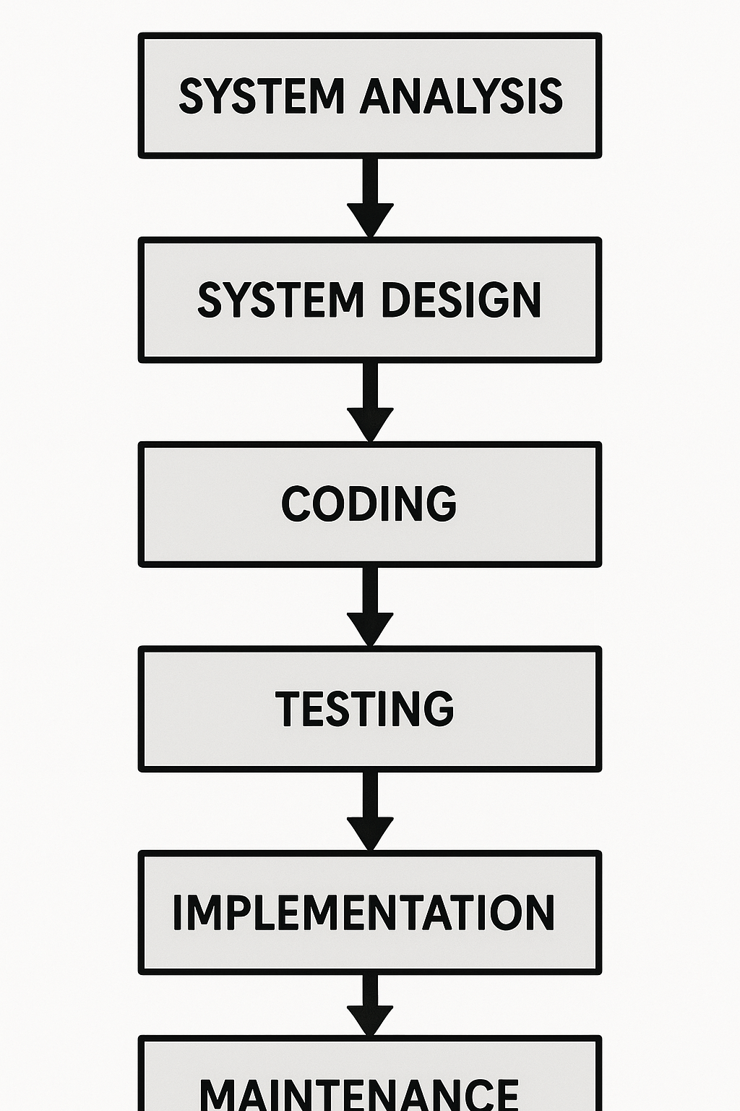

**Analysis Diagrams: Data Flow Diagram (DFD)**

**Introduction to Data Flow Diagrams (DFD)**

A **Data Flow Diagram (DFD)** is a visual representation of the flow of data within a system. It is used to illustrate how data moves between processes, external entities, and data stores. DFDs are crucial for analyzing and constructing information processes, helping designers and developers understand system functions, data movement, and interactions between different parts of a system.

**Components of a Data Flow Diagram (DFD)**

1. **Processes**:
   * **Definition**: A process represents a task or action that manipulates or transforms data.
   * **Symbol**: Typically shown as a circle or a rounded rectangle.
   * **Example**: A process might be "Process Payment," where data like payment details is processed to confirm a transaction.
2. **External Entities**:
   * **Definition**: External entities are sources or destinations of data that exist outside the system being modeled. They could be users, other systems, or databases.
   * **Symbol**: Typically shown as squares or rectangles.
   * **Example**: A "Customer" interacting with a system would be an external entity.
3. **Data Flow**:
   * **Definition**: A data flow represents the movement of data between processes, data stores, and external entities. The direction of the arrow indicates the direction of data flow.
   * **Symbol**: An arrow.
   * **Example**: Data such as "User Credentials" might flow from the user (external entity) to the "Login Process."
4. **Data Stores**:
   * **Definition**: A data store represents a place where data is stored. Data stores do not modify the data but simply hold it.
   * **Symbol**: Typically shown as two parallel lines or an open-ended rectangle.
   * **Example**: A "User Database" could store user information such as name, address, and preferences.
5. **Privilege Boundary**:
   * **Definition**: Represents a change in privilege levels as data flows through the system. It helps identify who has access to what data at different stages of the process.
   * **Symbol**: Usually represented by a dashed line that encloses a process or set of processes.

**Types of Data Flow Diagrams**

1. **Context-Level DFD (Level 0 DFD)**:
   * This is the highest-level diagram that shows the system as a single process. It highlights the system's boundaries and the interactions between the system and external entities (users, other systems).
2. **Level 1 DFD**:
   * This level breaks down the context-level DFD into more detailed processes and shows how the main system is broken down into subprocesses. It illustrates data flows between those subprocesses and data stores.
3. **Level 2 and Lower DFDs**:
   * These diagrams break down the subprocesses further into even more detailed steps. This level of DFD provides a granular view of the system’s internal processes.

**1. Processes**

* Represent operations that transform incoming data into outgoing data.
* Symbol: Circle or Rounded Rectangle
* Examples:
  + Create Poll
  + Cast Vote
  + View Results
  + Authenticate User/Admin

**2. External Entities**

* Actors that interact with the system (but are outside its boundaries).
* Symbol: Square or Rectangle
* Examples:
  + Admin
  + Voter (User)

**3. Data Stores**

* Hold or store data for later use.
* Symbol: Two parallel lines (= =) or an open rectangle
* Examples:
  + Poll Database
  + Vote Records
  + User Accounts

**4. Data Flow**

* Arrows representing the flow of data between components.
* Symbol: →
* Examples:
  + Login Data, Poll Details, Vote Data

**Advantages of Data Flow Diagrams**

* **Clear Communication**: DFDs provide an easy-to-understand representation of data flow, making it easier for stakeholders (like clients, developers, and analysts) to communicate system requirements.
* **Systematic Approach**: They allow developers to break down a complex system into manageable processes and identify bottlenecks, redundancies, and areas of improvement.
* **Process Visualization**: DFDs visually represent how data flows, how it is processed, and where it is stored, helping in understanding the underlying logic of the system.

**Conclusion**

DFDs are a powerful tool for analyzing and designing information systems, as they provide a detailed and systematic approach to representing data flow and system processes. By breaking down the system into different levels, DFDs make it easier to identify relationships between system components, analyze their functions, and design more efficient and effective systems.

**Level 0 DFD Diagram**

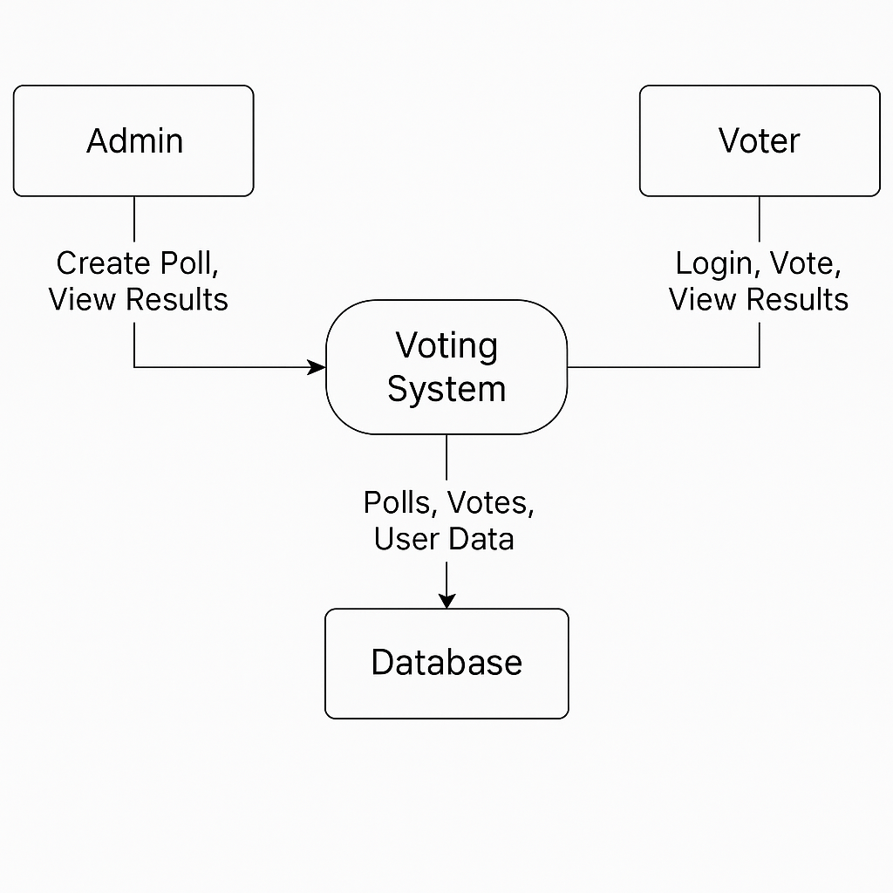

**Level 1 Diagram**

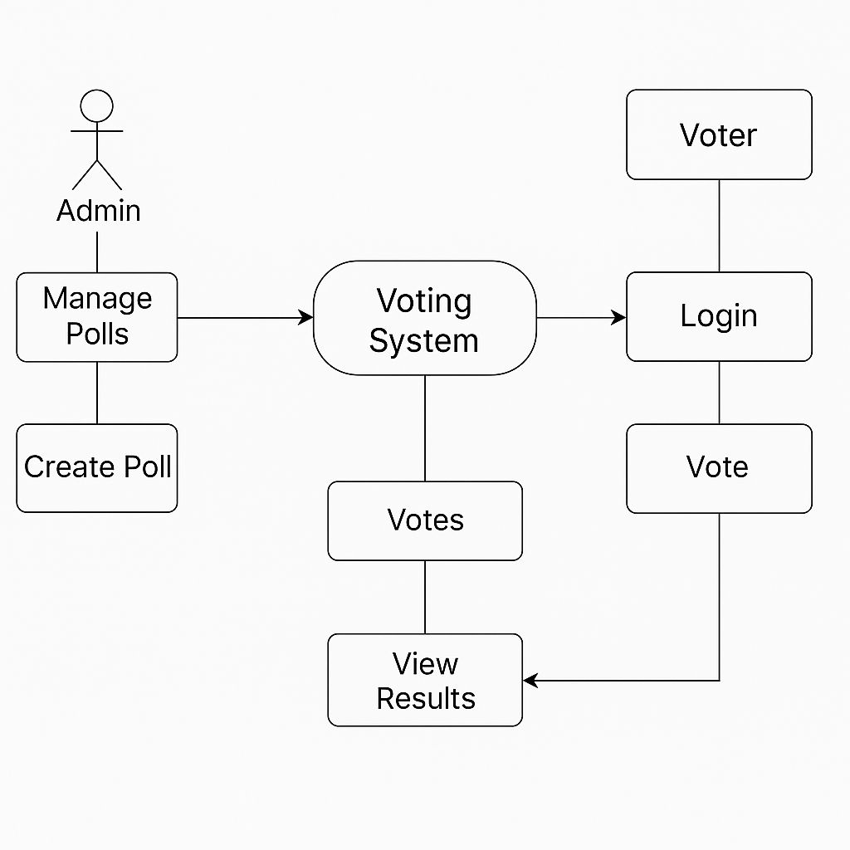

**Level 2 Diagram**

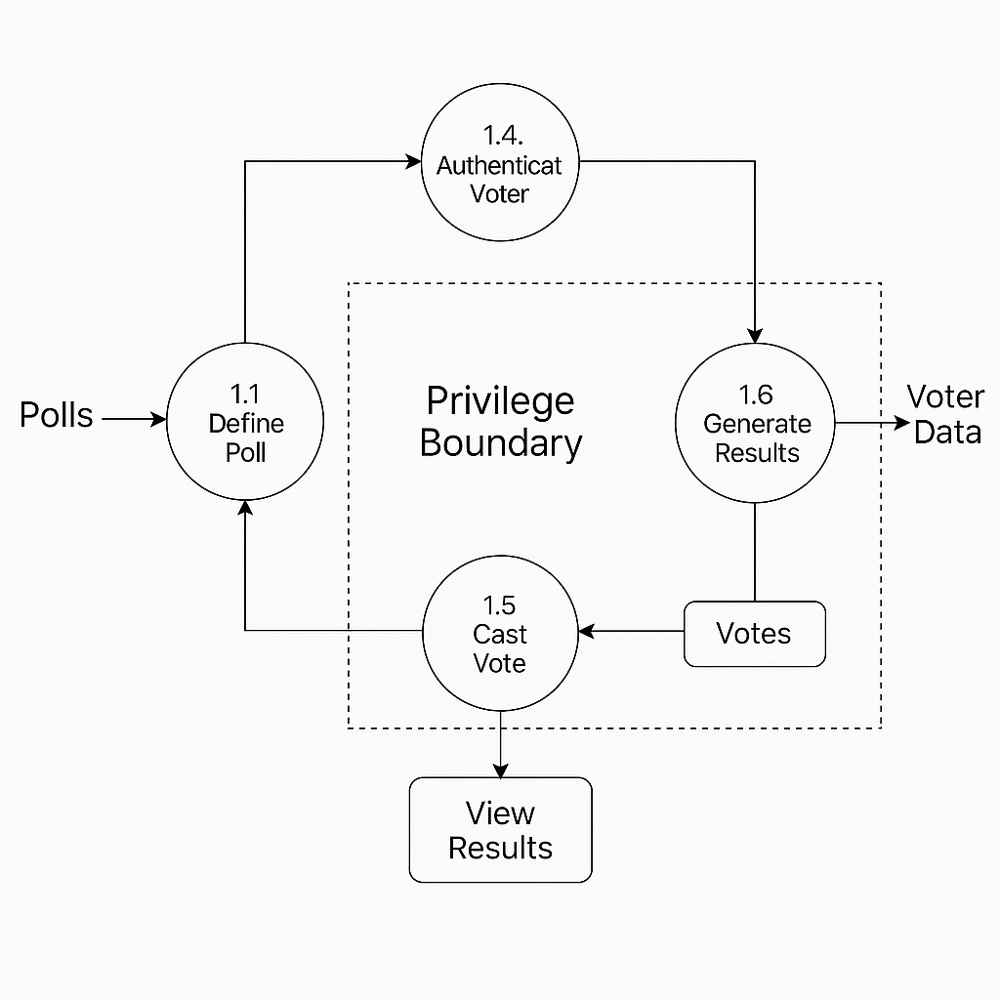

**ER Diagram :**

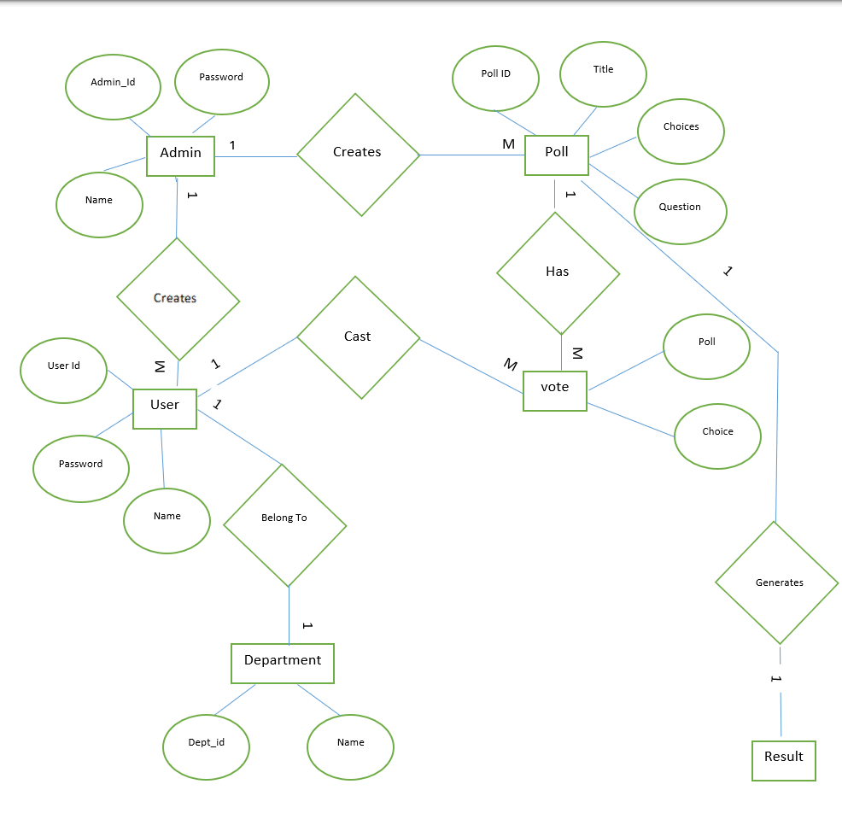

**System Design**

**a) User Registration**

Voters can register themselves to become eligible for voting. Once registered, they receive a unique ID, making future logins and participation secure and personalized.

**b) Candidate Management**

This section allows the admin to add, update, or remove candidates. It stores candidate information like name, party, symbol, and election details.

**c) Poll Creation**

Admins can create new polls/elections, set timeframes, and assign candidates to each poll. This module controls which polls are active and who can vote.

**d) Vote Casting**

Once a poll is live, registered users can log in and cast their vote. The system ensures one vote per user per poll and maintains voter anonymity.

**e) Result Display**

After the poll ends, results are computed and displayed. This module presents candidate-wise vote counts and declares winners.

**f) Admin Dashboard**

Admins get access to manage users, polls, and candidates. It includes features for monitoring system activity and handling disputes.

**g) Security & Verification**

This module handles authentication, user verification, and secure voting through OTPs, unique tokens, or email confirmation, ensuring voting integrity.

**DATA STRUCTURE OF ALL MODULES**

1. **Department Table**

|  |  |  |
| --- | --- | --- |
| Column Name | Data Type | Notes |
| ID | **Integer(pk)** | **Auto-increment primary key** |
| name | **Varchar(100)** | **Deparement Name** |

1. **Poll Table**

|  |  |  |
| --- | --- | --- |
| Column Name | Data Types | Notes |
| ID | Integer(PK) | Auto-increment primary key |
| Question | Varchar(200) | Poll question |
| Department | Varchar(100) | |  | | --- | |  |  |  | | --- | | Department name (as string, not FK) | |
| Title | Varchar(100) | Optional poll title, default "Poll Title" |
| Description | Text | Optional description, default "Poll Description" |
| Created_at | |  | | --- | |  |  |  | | --- | | DateTime | | |  | | --- | |  |  |  | | --- | | Auto timestamp on creation | |

1. **PollChoice Table**

|  |  |  |
| --- | --- | --- |
| Column Name | Data Types | Notes |
| ID | Integer(PK) | Auto-increment primary key |
| Poll_id | Integer(FK) | Foreign key referencing Poll(id) |
| choice | Varchar(200) | Choice option text |

1. **Vote Table**

|  |  |  |
| --- | --- | --- |
| Column Name | Data Types | Notes |
| ID | Integer(PK) | Auto-increment primary key |
| User_id | Integer(FK) | Foreign key referencing auth_user(id) (Django User model) |
| Poll_id | Integer(FK) | Foreign key referencing Poll(id) |
| vote_choice | Varchar(200) | Text representation of the vote choice |
| choice_id | Integer(FK) | Foreign key referencing PollChoice(id), nullable |

1. **User Table**

|  |  |  |
| --- | --- | --- |
| Column Name | Data Types | Notes |
| ID | Integer(PK) | Auto-increment primary key |
| Password | Varchar(128) | Hashed password |
| last_login | DateTime (null) | Last login timestamp (nullable) |
| is_superuser | Boolean | Superuser flag |
| username | Varchar(150) | Unique username |
| first_name | Varchar(150) | User's first name |
| last_name | Varchar(150) | User's last name |
| email | Varchar(254) | User email |
| is_staff | Boolean | Staff status flag |
| is_active | Boolean | Active status |
| date_joined | DateTime | Account creation timestamp |

**PROCEDURAL DESIGN**

PROCESS LOGIC (FLOWCHART ) OF EACH MODULE

|  |  |  |
| --- | --- | --- |
|  | **Notations Used For FLOW CHART** | |
| **NOTATIONS** |  | **USED FOR** |
|  | Known as  **TERMINATOR** | Used for START / STOP |
|  | Known as  **DATA** | Used for ACCEPTING INPUTS  FROM USER AND also  DISPLAYING THE ERROR  MESSAGES GENERATED BY THE SYSTEM |
|  | Known as  **DECISION** | Used for DECISION MAKING |
|  | Known as **DISPLAY** | Used for OUTPUT GENERATED BY THE SYSTEM |
|  | Known as  **MAGNETIC DISK** | Used for STORING INPUTS GIVEN TO THE SYSTEM |

**1** **Flow chart for Customer Registration(Admin Panel)**

**START**

Enter name, address,

User Info

If all the entered

data is valid?

YES

NO

Save into

Customer

Details

**STOP**

Generate uid

**2. Flow chart for PollVote**

**START**

Enter name, address,

Select choice

If Choice Selected

data is valid?

YES

NO

Save into

Vote Database

**STOP**

**3. Flow chart for Polls Creation Table**

Add Choices Related to Poll

NO

If all the entered

entered

NO

**START**

Enter name, address,

Add(Question, Title, Descripton)

If all the entered

YES

NO

Save into

Polls Table

**STOP**

1. **Flow chart for Department Table**

**START**

User Department

If all the entered

data is valid?

YES

NO

Save into

Users Department Table

**STOP**

**Screenshot**

**Login Page**

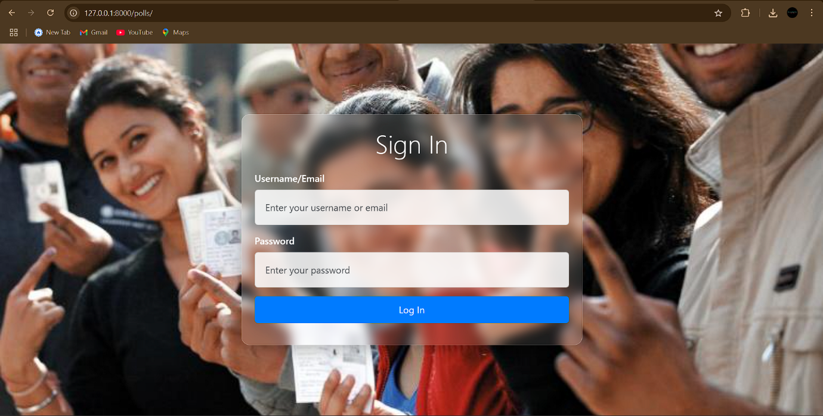

**Login Page with Validation**

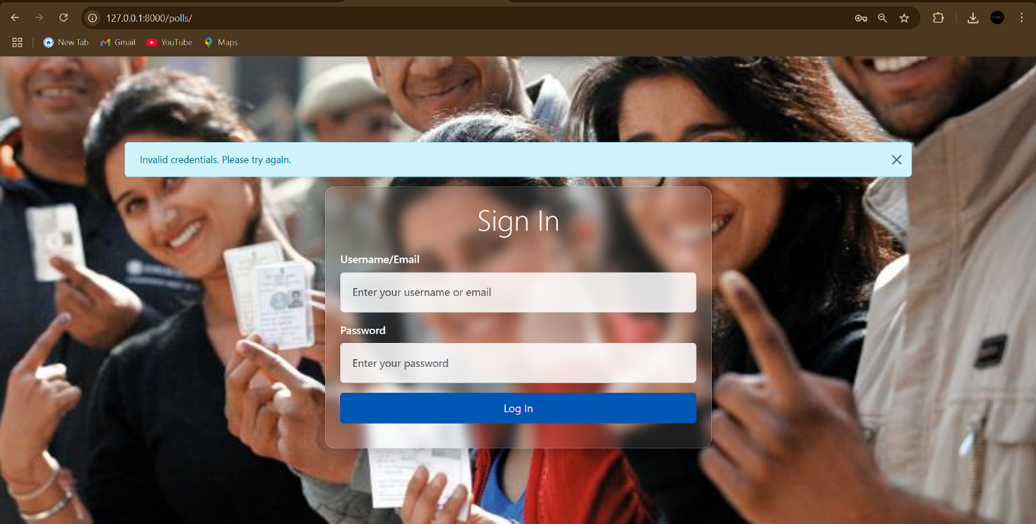

**Home Page**

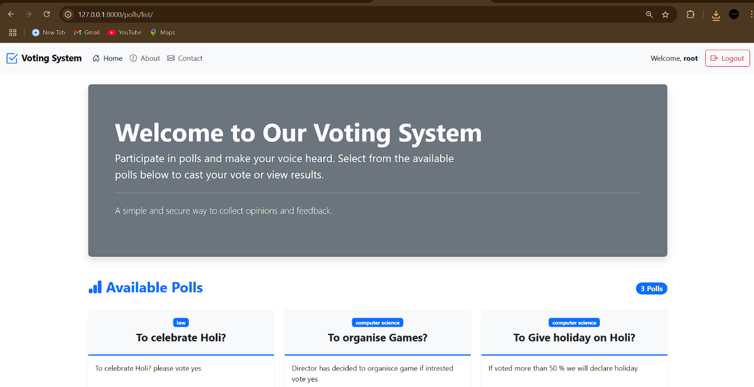

**Polls Page**

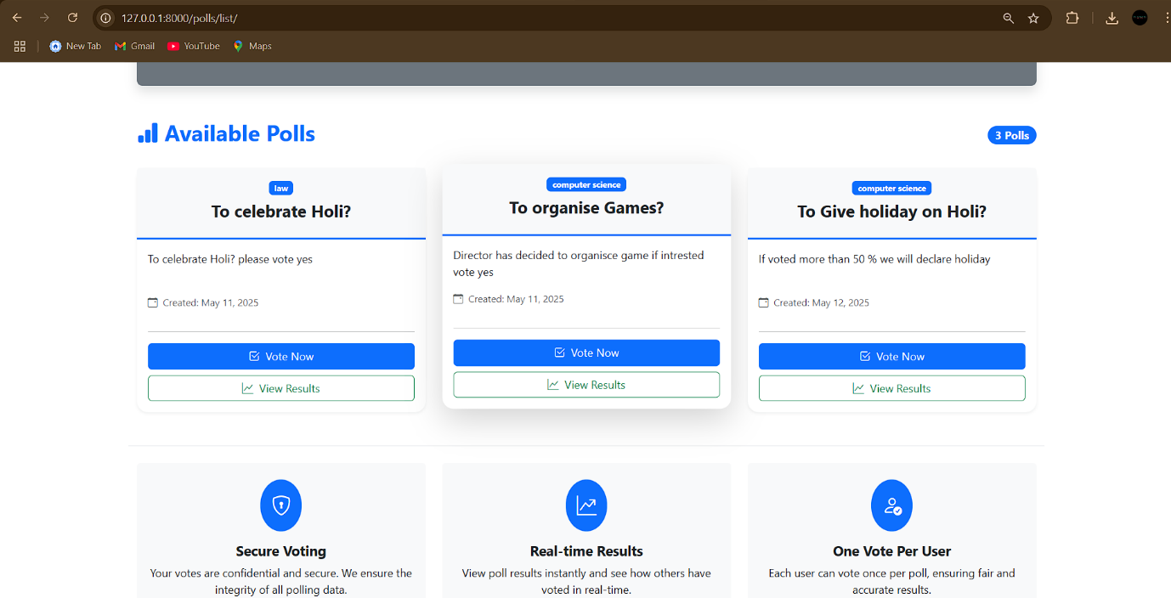

**Voting Page**

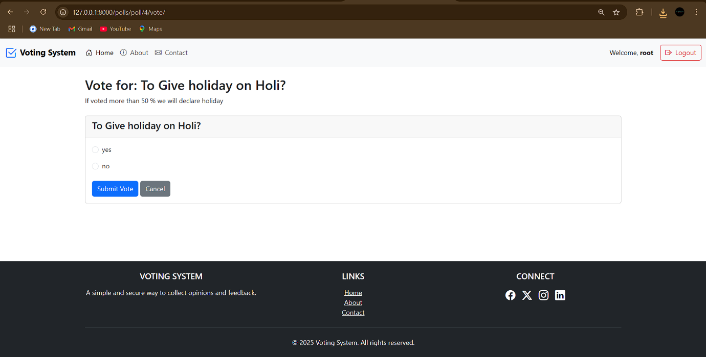

**If Already Voted Valadition**

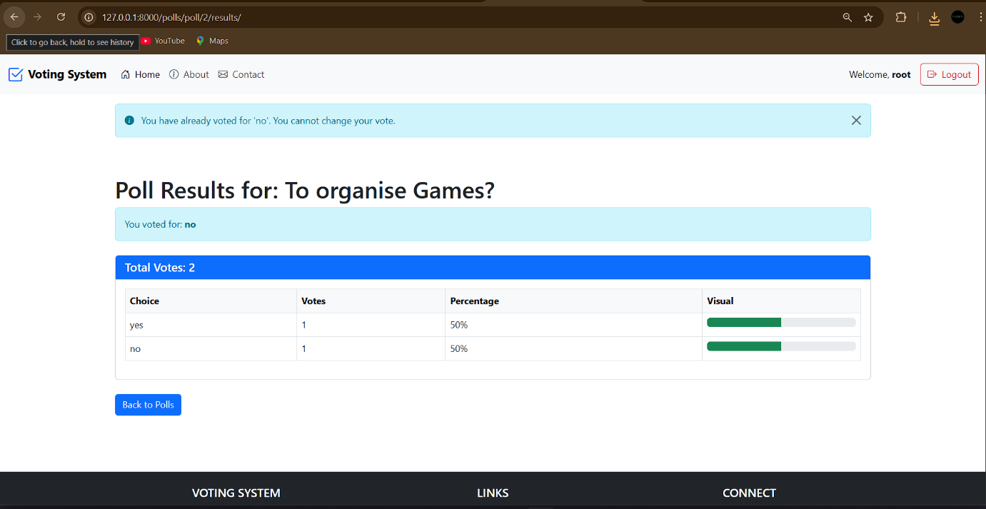

**Result Page**

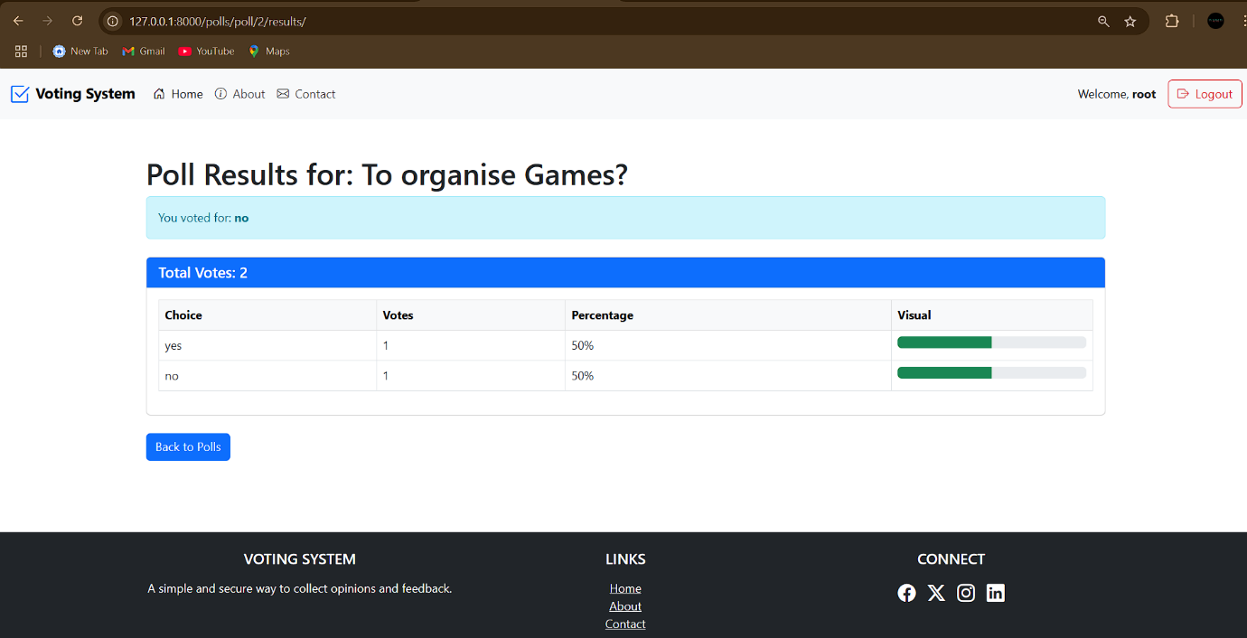

**5.1 CODE SAMPLE**

**Django Model.py**

from django.db import models# import models form django, db for intracting with database

from django.contrib.auth.models import User # To Aunthicate the user

# Department model

class Department(models.Model):

    name = models.CharField(max_length=100) # Creates table of name Department at Table

    def __str__(self): #To make data readble to user

        return self.name

# Poll model

class Poll(models.Model):

    question = models.CharField(max_length=200)#1

    department = models.CharField(max_length=100)

    title = models.CharField(max_length=200, default="Poll Title")  # Optional, for UI

    description = models.TextField(default="Poll Description")       # Optional, for UI

    created_at = models.DateTimeField(auto_now_add=True)

    def __str__(self):

        return self.title

# PollChoice model (Options for a poll)

class PollChoice(models.Model):

    poll = models.ForeignKey(Poll, on_delete=models.CASCADE, related_name="choices") #poll colum 1

    choice = models.CharField(max_length=200)

    def __str__(self):

        return self.choice

# Vote model (User's vote for a choice in a poll)

class Vote(models.Model):

    user = models.ForeignKey(User, on_delete=models.CASCADE)

    poll = models.ForeignKey(Poll, on_delete=models.CASCADE)

    vote_choice = models.CharField(max_length=200)

    choice = models.ForeignKey('PollChoice', on_delete=models.CASCADE, null=True, blank=True)

    class Meta:

        unique_together = ('user', 'poll')  # Ensures 1 vote per poll per user

    def __str__(self):

        choice_text = self.vote_choice

        if self.choice:

            choice_text = self.choice.choice

        return f"{self.user.username} voted for {choice_text}"

**Django Views.py**

from django.contrib.auth import authenticate, login as auth_login, logout

from django.shortcuts import render, redirect, get_object_or_404

from django.contrib.auth.decorators import login_required

from django.http import HttpResponse, Http404

from .models import Poll, PollChoice, Vote

from django.contrib import messages

from django.db.models import Count

def login_view(request):

    if request.method == 'POST':

        username = request.POST.get('username') # .get gets all data form html page when user click submin

        password = request.POST.get('password')

        if not username or not password: #checks if username or password is balank

            return HttpResponse("Username and password are required.")

        user = authenticate(request, username=username, password=password) # chek databae if user exist, if exist saves data in user Variable

        if user is not None:

            auth_login(request, user)

            return redirect('polls:polls_list')

        else:

            messages.info(request, "Invalid credentials. Please try again.")

            return redirect('polls:login')

    return render(request, 'polls/login.html') # if user first vist it shows login page

def logout_view(request):

    logout(request)

    return redirect('polls:login')

@login_required # to acces below page you need to login in fist , cannot see pages direclty thorough link

def index(request):

    return render(request, 'polls/index.html')

@login_required

def about(request):

    return render(request, 'polls/about.html')

@login_required

def contact(request):

    return render(request, 'polls/contact.html')

@login_required

def polls_list(request):

    polls = Poll.objects.all()

    return render(request, 'polls/polls_list.html', {'polls': polls})

@login_required

def vote(request, poll_id):

    poll = get_object_or_404(Poll, pk=poll_id) # get all poll data

    choices = PollChoice.objects.filter(poll=poll) # choices related to poll

    # Check if the user has already voted

    existing_vote = Vote.objects.filter(user=request.user, poll=poll).first() # check exixting vote and if exist make 'existing_vote' True or  if not False

    # If user has already voted, redirect to results and show message

    if existing_vote:

        messages.info(request, f"You have already voted for '{existing_vote.vote_choice}'. You cannot change your vote.")

        return redirect('polls:poll_results', poll_id=poll.id)

    if request.method == 'POST':

        choice_id = request.POST.get('vote_choice')

        if not choice_id:

            messages.error(request, "Please select a choice.")

            return render(request, 'polls/vote.html', {'poll': poll, 'choices': choices})

        choice = get_object_or_404(PollChoice, pk=choice_id)

        # Create new vote

        vote = Vote(

            user=request.user,

            poll=poll,

            choice=choice,

            vote_choice=choice.choice

        )

        vote.save()

        return redirect('polls:poll_results', poll_id=poll.id)

    return render(request, 'polls/vote.html', {'poll': poll, 'choices': choices})

@login_required

def poll_results(request, poll_id):

    poll = get_object_or_404(Poll, pk=poll_id)# get all polls related to id

    # Get all choices for this poll

    choices = PollChoice.objects.filter(poll=poll) #gets choices related to polls

    # Get all votes for this poll

    all_votes = Vote.objects.filter(poll=poll) #Get all polls votes related to this poll

    total_votes = all_votes.count() # count all votes

    # Count votes for each choice like Yes 4 and no 5

    choice_votes = []# [{Yes,5,50%},{No,5,50%}]

    for choice in choices:

        # Count votes where the choice field matches this choice

        votes_count = all_votes.filter(choice=choice).count()

        choice_votes.append({

            'choice': choice.choice,

            'count': votes_count,

            'percent': round((votes_count / total_votes) * 100) if total_votes > 0 else 0

        })

    # Get the user's vote for this poll

    user_vote = all_votes.filter(user=request.user).first() #ckecks if user voted or not

    # # Print debug info

    # print(f"DEBUG - Total votes: {total_votes}")

    # for cv in choice_votes:

    #     print(f"DEBUG - Choice: {cv['choice']}, Count: {cv['count']}, Percent: {cv['percent']}%")

    # if user_vote:

    #     print(f"DEBUG - User voted for: {user_vote.vote_choice}, Choice ID: {user_vote.choice_id}")

    return render(request, 'polls/results.html', {

        'poll': poll,

        'results': choice_votes,

        'total_votes': total_votes,

        'user_vote': user_vote

    }) # deliver this data to html page for show

**Django Urls.py**

from django.urls import path

from . import views

from django.contrib import admin

app_name = 'polls'  # This adds a namespace for the polls app

urlpatterns = [

    path('', views.login_view, name='login'),  # Login view

    path('index/', views.index, name='index'),  # Index view

    path('about/', views.about, name='about'),  # About page

    path('contact/', views.contact, name='contact'),  # Contact page

    path('logout/', views.logout_view, name='logout'),  # Logout view

    path('list/', views.polls_list, name='polls_list'),  # Polls list page

    path('poll/<int:poll_id>/vote/', views.vote, name='vote'),  # Vote on a specific poll

    path('poll/<int:poll_id>/results/', views.poll_results, name='poll_results'),  # Poll results page

**Django Admin.py**

from django.contrib import admin

from .models import Department, Poll, PollChoice, Vote

# PollChoiceInline to display PollChoice options directly within Poll's admin page

class PollChoiceInline(admin.TabularInline):  # Can also use admin.StackedInline

    model = PollChoice

    extra = 3  # This will add 3 empty fields for choices by default

    fields = ['choice']  # Display only the 'choice' field

# PollAdmin configuration

class PollAdmin(admin.ModelAdmin):

    list_display = ['question', 'department', 'created_at']  # Include created_at in the display

    inlines = [PollChoiceInline]  # Add PollChoiceInline to the Poll admin page

# Registering models with the admin site

admin.site.register(Department)

admin.site.register(Poll, PollAdmin)  # Register Poll with the customized PollAdmin

admin.site.register(PollChoice)

admin.site.register(Vote)

**Imp Html Templets**

**Index.html**

<!DOCTYPE html>

<html lang="en">

<head>

    <meta charset="UTF-8">

    <meta name="viewport" content="width=device-width, initial-scale=1.0">

    <title>{% block title %}Voting System{% endblock %}</title>

    <!-- Bootstrap CSS -->

    <link href="https://cdn.jsdelivr.net/npm/bootstrap@5.3.0-alpha1/dist/css/bootstrap.min.css" rel="stylesheet">

    <!-- Bootstrap Icons -->

    <link rel="stylesheet" href="https://cdn.jsdelivr.net/npm/bootstrap-icons@1.11.1/font/bootstrap-icons.css">

    <style>

        body {

            min-height: 100vh;

            display: flex;

            flex-direction: column;

        }

        .content-wrapper {

            flex: 1;

        }

        footer {

            margin-top: auto;

        }

    </style>

    {% block extra_css %}{% endblock %}

</head>

<body>

    <!-- Navigation -->

    <nav class="navbar navbar-expand-lg bg-body-tertiary">

        <div class="container-fluid">

            <a class="navbar-brand d-flex align-items-center" href="{% url 'polls:polls_list' %}">

                <i class="bi bi-check2-square me-2 text-primary fs-3"></i>

                <span class="fw-bold">Voting System</span>

            </a>

            <button class="navbar-toggler" type="button" data-bs-toggle="collapse" data-bs-target="#navbarNav" aria-controls="navbarNav" aria-expanded="false" aria-label="Toggle navigation">

                <span class="navbar-toggler-icon"></span>

            </button>

            <div class="collapse navbar-collapse justify-content-between" id="navbarNav">

                <ul class="navbar-nav">

                    <li class="nav-item">

                        <a class="nav-link active" aria-current="page" href="{% url 'polls:polls_list' %}">

                            <i class="bi bi-house-door me-1"></i> Home

                        </a>

                    </li>

                    <li class="nav-item">

                        <a class="nav-link" href="{% url 'polls:about' %}">

                            <i class="bi bi-info-circle me-1"></i> About

                        </a>

                    </li>

                    <li class="nav-item">

                        <a class="nav-link" href="{% url 'polls:contact' %}">

                            <i class="bi bi-envelope me-1"></i> Contact

                        </a>

                    </li>

                </ul>

                {% if user.is_authenticated %}

                <div class="d-flex align-items-center">

                    <span class="me-3">Welcome, <strong>{{ user.username }}</strong></span>

                    <form method="post" action="{% url 'polls:logout' %}" class="d-flex">

                        {% csrf_token %}

                        <button class="btn btn-outline-danger">

                            <i class="bi bi-box-arrow-right me-1"></i> Logout

                        </button>

                    </form>

                </div>

                {% endif %}

            </div>

        </div>

    </nav>

    <!-- Display messages -->

    {% if messages %}

    <div class="container mt-3">

        {% for message in messages %}

            <div class="alert alert-{{ message.tags }} alert-dismissible fade show" role="alert">

                {% if message.tags == 'success' %}<i class="bi bi-check-circle-fill me-2"></i>{% endif %}

                {% if message.tags == 'error' %}<i class="bi bi-exclamation-triangle-fill me-2"></i>{% endif %}

                {% if message.tags == 'info' %}<i class="bi bi-info-circle-fill me-2"></i>{% endif %}

                {% if message.tags == 'warning' %}<i class="bi bi-exclamation-circle-fill me-2"></i>{% endif %}

                {{ message }}

                <button type="button" class="btn-close" data-bs-dismiss="alert" aria-label="Close"></button>

            </div>

        {% endfor %}

    </div>

    {% endif %}

    <!-- Main Content -->

    <div class="content-wrapper">

        {% block content %}{% endblock %}

    </div>

    <!-- Footer -->

    <footer class="bg-dark text-white text-center py-4 mt-5">

        <div class="container">

            <div class="row">

                <div class="col-md-4 mb-3 mb-md-0">

                    <h5 class="text-uppercase mb-3">Voting System</h5>

                    <p class="mb-0">A simple and secure way to collect opinions and feedback.</p>

                </div>

                <div class="col-md-4 mb-3 mb-md-0">

                    <h5 class="text-uppercase mb-3">Links</h5>

                    <ul class="list-unstyled mb-0">

                        <li><a href="{% url 'polls:polls_list' %}" class="text-white">Home</a></li>

                        <li><a href="{% url 'polls:about' %}" class="text-white">About</a></li>

                        <li><a href="{% url 'polls:contact' %}" class="text-white">Contact</a></li>

                    </ul>

                </div>

                <div class="col-md-4">

                    <h5 class="text-uppercase mb-3">Connect</h5>

                    <div class="d-flex justify-content-center">

                        <a href="#" class="text-white me-3"><i class="bi bi-facebook fs-4"></i></a>

                        <a href="#" class="text-white me-3"><i class="bi bi-twitter-x fs-4"></i></a>

                        <a href="#" class="text-white me-3"><i class="bi bi-instagram fs-4"></i></a>

                        <a href="#" class="text-white"><i class="bi bi-linkedin fs-4"></i></a>

                    </div>

                </div>

            </div>

            <hr class="my-4">

            <p class="mb-0">&copy; {% now "Y" %} Voting System. All rights reserved.</p>

        </div>

    </footer>

  <!-- Bootstrap JS bundle -->

    <script src="https://cdn.jsdelivr.net/npm/bootstrap@5.3.0-alpha1/dist/js/bootstrap.bundle.min.js"></script>

</body>

</html>

**Polls_list.html**

{% extends 'polls/index.html' %}

{% block title %}Home | Voting System{% endblock %}

{% block content %}

<div class="container py-4">

    <!-- Hero Section -->

    <div class="p-5 mb-5 bg-secondary text-white rounded-3 shadow">

        <div class="container-fluid py-4">

            <h1 class="display-4 fw-bold">Welcome to Our Voting System</h1>

            <p class="col-md-8 fs-4">Participate in polls and make your voice heard. Select from the available polls below to cast your vote or view results.</p>

            <hr class="my-4 opacity-25">

            <p class="lead">A simple and secure way to collect opinions and feedback.</p>

        </div>

    </div>

    <!-- Polls Section -->

    <div class="mb-5">

        <div class="d-flex justify-content-between align-items-center mb-4">

            <h2 class="fw-bold text-primary"><i class="bi bi-bar-chart-fill me-2"></i>Available Polls</h2>

            <span class="badge bg-primary rounded-pill fs-6">{{ polls.count }} Poll{% if polls.count != 1 %}s{% endif %}</span>

        </div>

        {% if polls %}

            <div class="row row-cols-1 row-cols-md-2 row-cols-lg-3 g-4">

                {% for poll in polls %}

                    <div class="col">

                        <div class="card h-100 rounded-4 shadow-sm border-0 transition-hover">

                            <div class="card-header bg-light py-3 text-center border-bottom border-primary border-3">

                                <span class="badge bg-primary mb-2">{{ poll.department }}</span>

                                <h4 class="card-title fw-bold">{{ poll.title }}</h4>

                            </div>

                            <div class="card-body d-flex flex-column">

                                <p class="card-text flex-fill">{{ poll.description }}</p>

                                <div class="d-flex text-muted mb-3 small">

                                    <div><i class="bi bi-calendar-event me-1"></i> Created: {{ poll.created_at|date:"M d, Y" }}</div>

                                </div>

                                <hr>

                                <div class="d-grid gap-2">

                                    <a href="{% url 'polls:vote' poll.id %}" class="btn btn-primary">

                                        <i class="bi bi-check2-square me-1"></i> Vote Now

                                    </a>

                                    <a href="{% url 'polls:poll_results' poll.id %}" class="btn btn-outline-success">

                                        <i class="bi bi-graph-up me-1"></i> View Results

                                    </a>

                                </div>

                            </div>

                        </div>

                    </div>

                {% endfor %}

            </div>

        {% else %}

            <div class="alert alert-info">

                <i class="bi bi-info-circle-fill me-2"></i> No polls are available at this time. Please check back later.

            </div>

        {% endif %}

    </div>

    <!-- Info Section -->

    <div class="row mt-5 pt-4 border-top">

        <div class="col-md-4 mb-4">

            <div class="card bg-light border-0 h-100">

                <div class="card-body py-4">

                    <div class="d-flex justify-content-center mb-3">

                        <div class="p-3 bg-primary rounded-circle text-white">

                            <i class="bi bi-shield-lock fs-3"></i>

                        </div>

                    </div>

                    <h5 class="card-title text-center fw-bold">Secure Voting</h5>

                    <p class="card-text text-center">Your votes are confidential and secure. We ensure the integrity of all polling data.</p>

                </div>

            </div>

        </div>

        <div class="col-md-4 mb-4">

            <div class="card bg-light border-0 h-100">

                <div class="card-body py-4">

                    <div class="d-flex justify-content-center mb-3">

                        <div class="p-3 bg-primary rounded-circle text-white">

                            <i class="bi bi-graph-up-arrow fs-3"></i>

                        </div>

                    </div>

                    <h5 class="card-title text-center fw-bold">Real-time Results</h5>

                    <p class="card-text text-center">View poll results instantly and see how others have voted in real-time.</p>

                </div>

            </div>

        </div>

        <div class="col-md-4 mb-4">

            <div class="card bg-light border-0 h-100">

                <div class="card-body py-4">

                    <div class="d-flex justify-content-center mb-3">

                        <div class="p-3 bg-primary rounded-circle text-white">

                            <i class="bi bi-person-check fs-3"></i>

                        </div>

                    </div>

                    <h5 class="card-title text-center fw-bold">One Vote Per User</h5>

                    <p class="card-text text-center">Each user can vote once per poll, ensuring fair and accurate results.</p>

                </div>

            </div>

        </div>

    </div>

</div>

{% endblock %}

{% block extra_css %}

<style>

    .transition-hover {

        transition: transform 0.3s ease, box-shadow 0.3s ease;

    }

    .transition-hover:hover {

        transform: translateY(-5px);

        box-shadow: 0 1rem 3rem rgba(0,0,0,.175)!important;

    }

</style>

{% endblock %}

**Vote.html**

{% extends 'polls/index.html' %}

{% block title %}Vote | Voting System{% endblock %}

{% block content %}

<div class="container py-4">

    <h2>Vote for: {{ poll.title }}</h2>

    <p class="mb-4">{{ poll.description }}</p>

    <div class="card mb-4">

        <div class="card-header">

            <h4>{{ poll.question }}</h4>

        </div>

        <div class="card-body">

            <form method="POST">

                {% csrf_token %}

                {% for choice in choices %}

                    <div class="form-check mb-3">

                        <input

                            type="radio"

                            class="form-check-input"

                            id="choice_{{ choice.id }}"

                            name="vote_choice"

                            value="{{ choice.id }}"

                            required

                        >

                        <label class="form-check-label" for="choice_{{ choice.id }}">

                            {{ choice.choice }}

                        </label>

                    </div>

                {% endfor %}

                <div class="mt-4">

                    <button type="submit" class="btn btn-primary">Submit Vote</button>

                    <a href="{% url 'polls:polls_list' %}" class="btn btn-secondary">Cancel</a>

                </div>

            </form>

        </div>

    </div>

</div>

{% endblock %}

**results.html**

{% extends 'polls/index.html' %}

{% block title %}Results | Voting System{% endblock %}

{% block content %}

<div class="container py-5">

    <h1>Poll Results for: {{ poll.question }}</h1>

    {% if user_vote %}

        <div class="alert alert-info mb-4">

            You voted for: <strong>{{ user_vote.vote_choice }}</strong>

        </div>

    {% endif %}

    {% if total_votes > 0 %}

        <div class="card mb-4">

            <div class="card-header bg-primary text-white">

                <h5 class="mb-0">Total Votes: {{ total_votes }}</h5>

            </div>

            <div class="card-body">

                <table class="table table-bordered">

                    <thead class="table-light">

                        <tr>

                            <th>Choice</th>

                            <th>Votes</th>

                            <th>Percentage</th>

                            <th>Visual</th>

                        </tr>

                    </thead>

                    <tbody>

                        {% for result in results %}

                            <tr>

                                <td>{{ result.choice }}</td>

                                <td>{{ result.count }}</td>

                                <td>{{ result.percent }}%</td>

                                <td>

                                    <div class="progress">

                                        <div class="progress-bar bg-success" role="progressbar" style="width: {{ result.percent }}%" aria-valuenow="{{ result.percent }}" aria-valuemin="0" aria-valuemax="100"></div>

                                    </div>

                                </td>

                            </tr>

                        {% endfor %}

                    </tbody>

                </table>

            </div>

        </div>

    {% else %}

        <div class="alert alert-warning">

            <p>No votes have been cast yet for this poll.</p>

        </div>

    {% endif %}

  <div class="d-flex gap-2">

        <a href="{% url 'polls:polls_list' %}" class="btn btn-primary">Back to Polls</a>

        {% if not user_vote %}

            <a href="{% url 'polls:vote' poll.id %}" class="btn btn-success">Vote Now</a>

        {% endif %}

    </div>

</div>

{% endblock %}

**login.html**

<!DOCTYPE html>

<html lang="en">

<head>

  <meta charset="UTF-8" />

  <meta name="viewport" content="width=device-width, initial-scale=1.0"/>

  <title>Sign In | Voting System</title>

  <link href="https://cdn.jsdelivr.net/npm/bootstrap@5.3.0-alpha1/dist/css/bootstrap.min.css" rel="stylesheet"/>

  <style>

    body {

      background-image: url('https://akm-img-a-in.tosshub.com/indiatoday/images/story/201903/GettyImages-462917270_1.jpeg?VersionId=v_bjPXBI84AeKZ7YeoUEErqP0Mzvq4Ci');

      background-size: cover;

      background-position: center;

      height: 100vh;

      margin: 0;

      display: flex;

      align-items: center;

      justify-content: center;

    }

    .card {

      background: rgba(255, 255, 255, 0.1);

      backdrop-filter: blur(10px);

      -webkit-backdrop-filter: blur(10px);

      border-radius: 15px;

      box-shadow: 0 8px 32px rgba(0, 0, 0, 0.3);

      border: 1px solid rgba(255, 255, 255, 0.3);

      color: #fff;

    }

    .form-label {

      font-size: 1.1rem;

      font-weight: 500;

      color: #fff;

    }

    .form-control {

      font-size: 1.1rem;

      padding: 1.2rem;

      border-radius: 6px;

      border: 1px solid #ccc;

      background-color: rgba(255, 255, 255, 0.85);

    }

    .btn-primary {

      background-color: #007bff;

      border: none;

      padding: 12px;

      font-size: 1.1rem;

    }

    .btn-primary:hover {

      background-color: #0056b3;

    }

    h1 {

      color: #fff;

    }

  </style>

</head>

<body>

  <div class="container py-5">

    <div class="row justify-content-center">

       {% if messages %}

    <div class="container mt-3">

        {% for message in messages %}

            <div class="alert alert-{{ message.tags }} alert-dismissible fade show" role="alert">

                {% if message.tags == 'success' %}<i class="bi bi-check-circle-fill me-2"></i>{% endif %}

                {% if message.tags == 'error' %}<i class="bi bi-exclamation-triangle-fill me-2"></i>{% endif %}

                {% if message.tags == 'info' %}<i class="bi bi-info-circle-fill me-2"></i>{% endif %}

                {% if message.tags == 'warning' %}<i class="bi bi-exclamation-circle-fill me-2"></i>{% endif %}

                {{ message }}

                <button type="button" class="btn-close" data-bs-dismiss="alert" aria-label="Close"></button>

            </div>

        {% endfor %}

    </div>

    {% endif %}

      <div class="col-md-6">

        <div class="card p-4">

          <h1 class="display-5 text-center mb-4">Sign In</h1>

          <form method="POST">

            {% csrf_token %}

            <div class="form-group mb-3">

              <label for="username" class="form-label">Username/Email</label>

              <input type="text" class="form-control" id="username" name="username" required placeholder="Enter your username or email">

            </div>

            <div class="form-group mb-3">

              <label for="password" class="form-label">Password</label>

              <input type="password" class="form-control" id="password" name="password" required placeholder="Enter your password">

            </div>

            <div class="text-center mb-3">

              <button type="submit" class="btn btn-primary w-100">Log In</button>

            </div>

          </form>

        </div>

      </div>

    </div>

  </div>

  <script src="https://cdn.jsdelivr.net/npm/@popperjs/core@2.11.6/dist/umd/popper.min.js"></script>

  <script src="https://cdn.jsdelivr.net/npm/bootstrap@5.3.0-alpha1/dist/js/bootstrap.min.js"></script>

</body>

</html>

**5.2 Validation Check**

Software testing is an essential aspect of ensuring software quality. It includes both **Verification and Validation (V & V)**:

* **Verification** confirms whether the product is being built correctly.
* **Validation** ensures the right product is being built as per user requirements.

**Boehm’s states this another way:**

* **Verification**: “Are we building the product right?”
* **Validation**: “Are we building the right product?”

Validation types implemented in the **Voting System** include:

* **Empty Field Validation**
* **Credential Validation**

**Empty Field Validation**

This validation checks if all mandatory fields—like **Email** and **Password**—are filled in before allowing the user to log in or register.

If the user tries to submit the form without entering an email or password, an error message is displayed prompting them to complete the missing information.

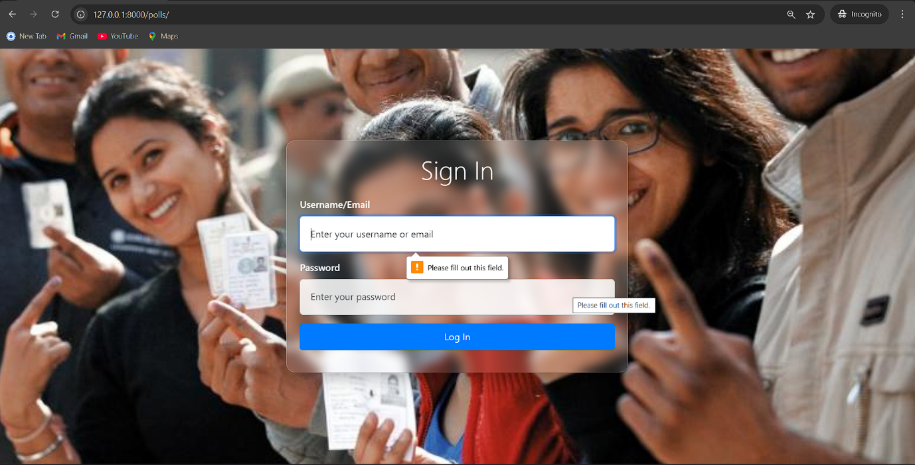

**Credential Validation**

This validation ensures that the **email and password combination** entered by the user matches the existing records in the system database.

If the credentials do not match, the system displays an error message like **"Invalid credentials"**, preventing unauthorized access.

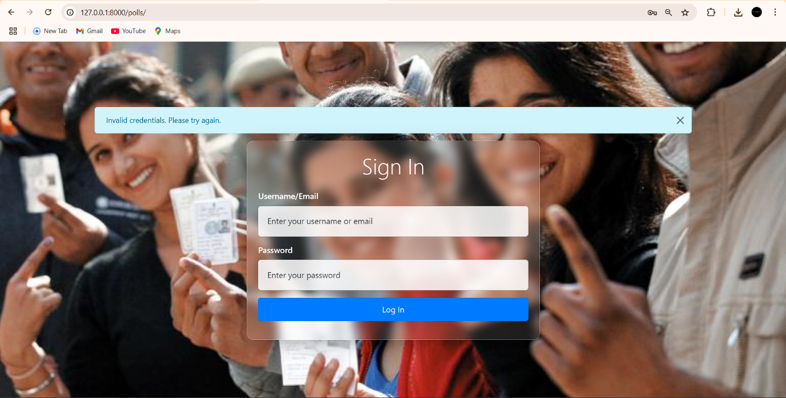

**6. TESTING**

Testing is a critical phase in the development of any software system. It ensures that the software performs as expected under all conditions and meets the specified requirements.

**Test Plan**

The test plan involves systematic activities such as defining test objectives, designing test cases, executing tests, and documenting results. It aims to find defects and verify that the software functions correctly.

**Types of Testing Performed:**

**5.1 Black Box Testing (Data Validation Testing):**

Black box testing is performed without knowing the internal structure or code. It focuses on inputs and outputs of the system.

|  |  |  |  |
| --- | --- | --- | --- |
| **Test Case ID** | **Input** | **Expected Output** | **Result** |
| TC01 | Valid voter login details | Redirect to voting page | Passed |
| TC02 | Invalid credentials | Show error message | Passed |
| TC03 | Vote submission once | Success message | Passed |
| TC04 | Repeat vote attempt | Block or error message | Passed |

**8.2 White Box Testing (Functional Validation Testing):**

White box testing includes examining code structure, logic, and paths.

|  |  |  |  |  |
| --- | --- | --- | --- | --- |
| Test Case ID | Function Tested | Expected Behavior | Actual Result | Status |
| TC05 | Vote count update | Vote count increments | As expected | Passed |
| TC06 | Session management | Only logged-in users vote | As expected | Passed |
| TC07 | Admin dashboard | Displays correct results | As expected | Passed |

**Tools Used for Testing:**

* Django’s built-in test framework
* Postman for API and route testing
* Manual UI testing using browsers

**Bug Tracking:**

Bugs discovered were logged and prioritized. Fixes were applied iteratively after re-testing.

**Testing Summary:**

* All major modules have been tested
* Edge cases and invalid inputs handled
* Application is functioning as expected under test conditions

**7.REPORT**

The Report Module in the Voting System displays a comprehensive summary of the election process. It provides a detailed overview of the voting outcomes and helps administrators monitor the progress and results efficiently.

This module plays an essential role in maintaining transparency, ensuring accuracy, and simplifying result declaration.

**Key Features of the Report Module:**

**Candidate List**: Displays the names of all registered candidates.

**Vote Count**: Shows the total number of votes received by each candidate.

**Live Updates**: Vote counts update in real time as users cast their votes

**Leading Candidate**: Highlights the candidate currently leading based on votes.

**Voting Statistics:** Presents data as a bar graph, pie chart, or table for better visualization.

**Total Voters Count**: Shows the number of users who participated in the voting process.

**Export Option**: Admin can export the report in PDF or Excel format for record-keeping (optional f

**Example Screenshots**

Screenshot 1: Table showing candidate names

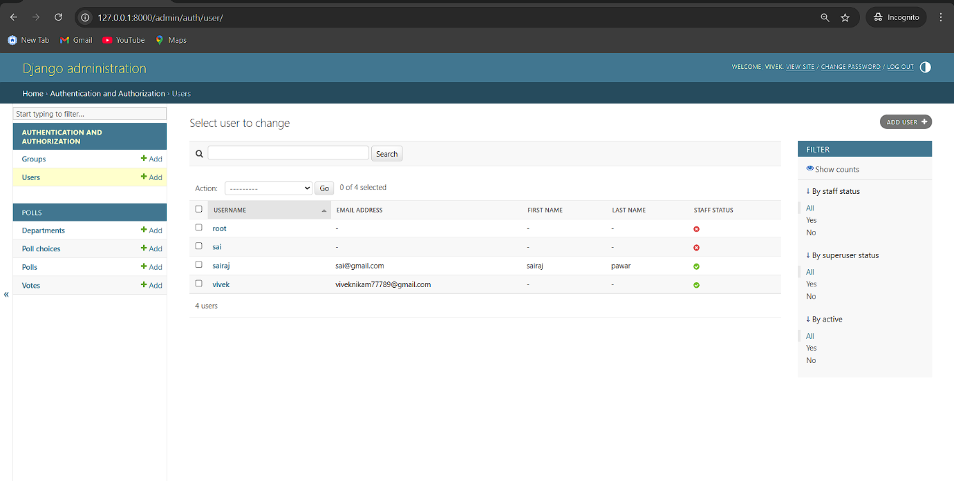

Screenshot 2: Graph chart representing vote distribution

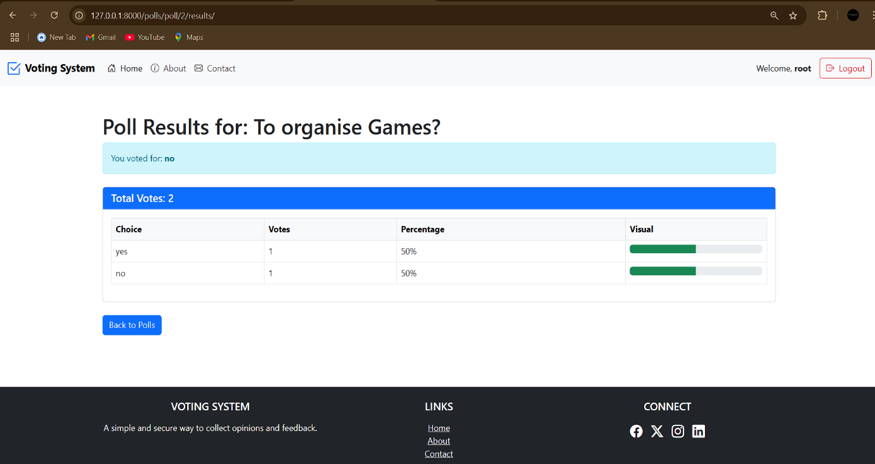

Screenshot 3: Total voter count or export button

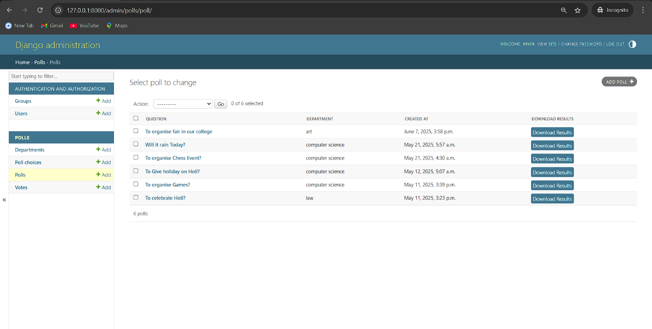

**FUTURE SCOPE**

The Online Voting System, as developed in this project, is functional and reliable for small-scale and institutional use cases. However, as technology and user demands evolve, there are multiple opportunities to expand and enhance the system. The following points outline potential future developments:

**1. Integration of Biometric Authentication**

To further increase security and prevent impersonation, biometric authentication such as fingerprint or facial recognition can be introduced.

**2. OTP and Email-Based Voter Verification**

Integrating One-Time Password (OTP) verification via SMS or email can ensure real-time validation of voter identity before casting a vote.

**3. Blockchain-Based Voting Ledger**

Incorporating blockchain technology can enhance transparency and auditability by creating a tamper-proof voting ledger that cannot be altered post-voting.

**4. Mobile Application Support**

Developing a mobile version of the application for Android and iOS platforms can improve accessibility and increase voter participation.

**5. Multilingual Interface**

Adding support for multiple languages in the user interface will make the system accessible to a diverse population.

**6. Real-Time Analytics Dashboard**

An admin dashboard displaying real-time analytics such as live voting counts, voter turnout percentage, and demographic summaries could be added.

**7. Geolocation Validation**

Geofencing or location-based validations can be implemented to restrict or allow voting access based on geographical eligibility.

**8. Third-Party Audit Integration**

Allowing external auditing bodies to independently verify election results and system logs could increase trust and accountability.

**9. Scalability for National-Level Elections**

With necessary legal compliance and infrastructure, the system can be scaled to handle state-level or national elections.

**CONCLUSION**

The Online Voting System developed as part of this project represents a significant step toward modernizing and streamlining the voting process in various organizations and academic institutions. Through the implementation of web-based technologies and secure authentication mechanisms, this system addresses many of the limitations associated with traditional paper-based voting methods.

**Key Takeaways:**

* The system simplifies the process of conducting elections, making it faster, more secure, and accessible.
* It eliminates manual counting and reduces human error, increasing the accuracy and reliability of election results.
* It introduces accountability and transparency into the voting process through the proper use of logs and result storage.

**Project Learnings:**

* Gained experience in full-stack development using technologies like Python, Django, MySQL, HTML, and CSS.
* Understood the importance of secure design practices and user authentication in sensitive systems.
* Learned the value of testing, documentation, and iterative development.

**Impact and Usability:**

* The system can be easily adapted and deployed in educational institutions, clubs, associations, or small-scale political groups.
* It reduces logistical effort, paper consumption, and administrative burden.

The project has achieved its goals within the defined scope and demonstrated the potential of digital transformation in democratic processes. With additional enhancements and regulatory support, such systems can be scaled for broader usage.

**BIBLIOGRAPHY**

The following books, journals, and academic resources were referred to during the development of the Online Voting System:

1. **Roger S. Pressman** – *Software Engineering: A Practitioner's Approach*, McGraw-Hill Education.
2. **Ian Sommerville** – *Software Engineering*, Pearson Education.
3. **E. Balagurusamy** – *Programming in Python*, McGraw-Hill.
4. **Database System Concepts** by Abraham Silberschatz, Henry F. Korth, S. Sudarshan – McGraw-Hill.
5. **Object Oriented Modeling and Design** by James Rumbaugh.

These references provided foundational knowledge in software engineering, database management, system design, and Python programming required for the execution of the project.

**REFERENCES**

1. Django Software Foundation. (n.d.). *Django Documentation (4.x)*. Retrieved from <https://docs.djangoproject.com/>.
2. Oracle Corporation. (n.d.). *MySQL Reference Manual*. Retrieved from <https://dev.mysql.com/doc/>
3. W3Schools. (n.d.). *HTML, CSS, and JavaScript Tutorials*. Retrieved from <https://www.w3schools.com/>
4. Mozilla Developer Network (MDN). (n.d.). *Web Development Documentation*. Retrieved from <https://developer.mozilla.org/>
5. Bootstrap. (n.d.). *Bootstrap 5 Documentation*. Retrieved from <https://getbootstrap.com/>
6. GitHub. (n.d.). *Various open-source code snippets used for logic and structure (where applicable)*.
7. ChatGPT by OpenAI. (2025). *Assistance in writing and debugging code logic for Django views, models, and templates.*